Experiment No: 05 Machine Learning

Aim:
Build a logistic regression classifier for spam detection, evaluating with precision-recall curves.

Objective:
- To understand the use of Logistic Regression for text classification.
- To learn feature extraction using TF-IDF for SMS spam dataset.
- To evaluate classification models using Precision-Recall curves and Average Precision.
- To analyze confusion matrix and classification report for performance assessment.

Prerequisites:
- Software: Python 3.x installed with libraries: pandas, scikit-learn, matplotlib.
- Hardware: A computer with at least 4 GB RAM.
- Skills: Basic Python programming, ML basics, handling datasets.

Theory:
Logistic Regression is a linear model commonly used for binary classification tasks. It estimates the probability that a given input belongs to a particular class using the sigmoid function.
In text classification, feature extraction plays a key role. The Term Frequency–Inverse Document Frequency (TF-IDF) method converts text into numerical feature vectors.
Precision-Recall curves are useful evaluation tools for imbalanced datasets. They show the trade-off between precision and recall for different thresholds. Average Precision (AP) summarizes the curve in a single value.

Apparatus/Software Requirements:
- Python IDE (Jupyter Notebook or any editor).
- Required Python libraries: pandas, scikit-learn, matplotlib.
- SMS Spam Dataset (label + message format).

Procedure:
Step 1: Load SMS Spam dataset and inspect structure.
Step 2: Preprocess labels (ham=0, spam=1).
Step 3: Split dataset into training and testing sets.
Step 4: Transform messages using TF-IDF Vectorizer.
Step 5: Train Logistic Regression classifier.
Step 6: Evaluate model using Precision-Recall curves and Average Precision.
Step 7: Generate confusion matrix and classification report.

Program Code:
import pandas as pd
from sklearn.feature_extraction.text import TfidfVectorizer
from sklearn.model_selection import train_test_split
from sklearn.linear_model import LogisticRegression
from sklearn.metrics import precision_recall_curve, average_precision_score, classification_report, confusion_matrix
import matplotlib.pyplot as plt
# Load dataset
df = pd.read_csv('sms_spam_dataset.csv', sep='\t', header=None, names=['label', 'message'])
df['label_num'] = df['label'].map({'ham': 0, 'spam': 1})
# Split data
X_train, X_test, y_train, y_test = train_test_split(df['message'], df['label_num'], test_size=0.2, random_state=42, stratify=df['label_num'])
# TF-IDF feature extraction
vectorizer = TfidfVectorizer(stop_words='english')
X_train_tfidf = vectorizer.fit_transform(X_train)
X_test_tfidf = vectorizer.transform(X_test)
# Logistic Regression model
clf = LogisticRegression(max_iter=1000)
clf.fit(X_train_tfidf, y_train)
# Evaluate with PR Curve
y_scores = clf.predict_proba(X_test_tfidf)[:, 1]
precision, recall, thresholds = precision_recall_curve(y_test, y_scores)
avg_precision = average_precision_score(y_test, y_scores)
# Plot PR Curve
plt.figure(figsize=(8,6))
plt.plot(recall, precision, label=f'LogReg (AP={avg_precision:.2f})')
plt.xlabel("Recall")
plt.ylabel("Precision")
plt.title("Precision-Recall Curve (Spam Detection)")
plt.legend()
plt.grid(True)
plt.show()
# Confusion Matrix & Report
print(confusion_matrix(y_test, clf.predict(X_test_tfidf)))
print(classification_report(y_test, clf.predict(X_test_tfidf), target_names=['ham','spam']))

Expected Output:

- Display dataset shape and distribution of ham/spam.

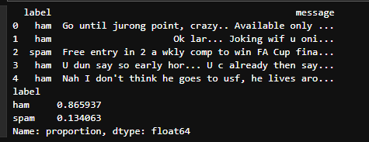
- Quick peek. (head)

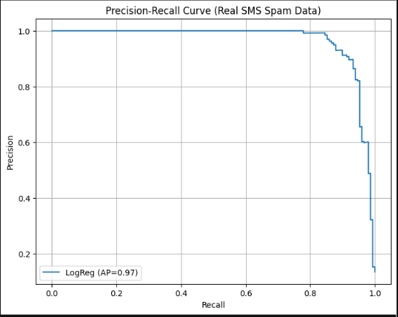
- Precision-Recall curve plotted with Average Precision displayed in legend.

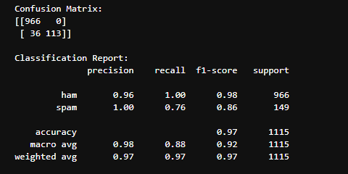
- Confusion Matrix showing classification performance.
- Classification Report including precision, recall, f1-score and accuracy.

Observations:
The Logistic Regression classifier achieves high performance in distinguishing spam from ham messages. The Precision-Recall curve indicates model stability even under class imbalance. Confusion matrix and report provide detailed error analysis.

Conclusion:
This lab demonstrated spam detection using Logistic Regression with TF-IDF feature extraction. Evaluation with Precision-Recall curves showed robust performance, confirming Logistic Regression as a strong baseline for binary text classification tasks.

Viva Questions:
- What is the role of TF-IDF in text classification?
- Why use Precision-Recall curves instead of ROC curves for imbalanced datasets?
- How does Logistic Regression estimate class probabilities?
- What are the limitations of Logistic Regression for text data?

